

To Whom It May Concern:

It gives me immense pleasure to write in recommendation of Mari's Property Management & Cleaning Services. I have had Mari's Cleaning Service for over four years.

Mari's staff has been very professional, hardworking, energetic and most important trustworthy.

I have no doubt that Mari's Property Management & Cleaning Service will have a positive impact to your business and like our company you will never want to search again.

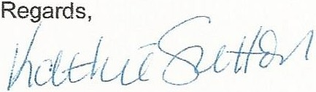

Kathie Sletton

Owner