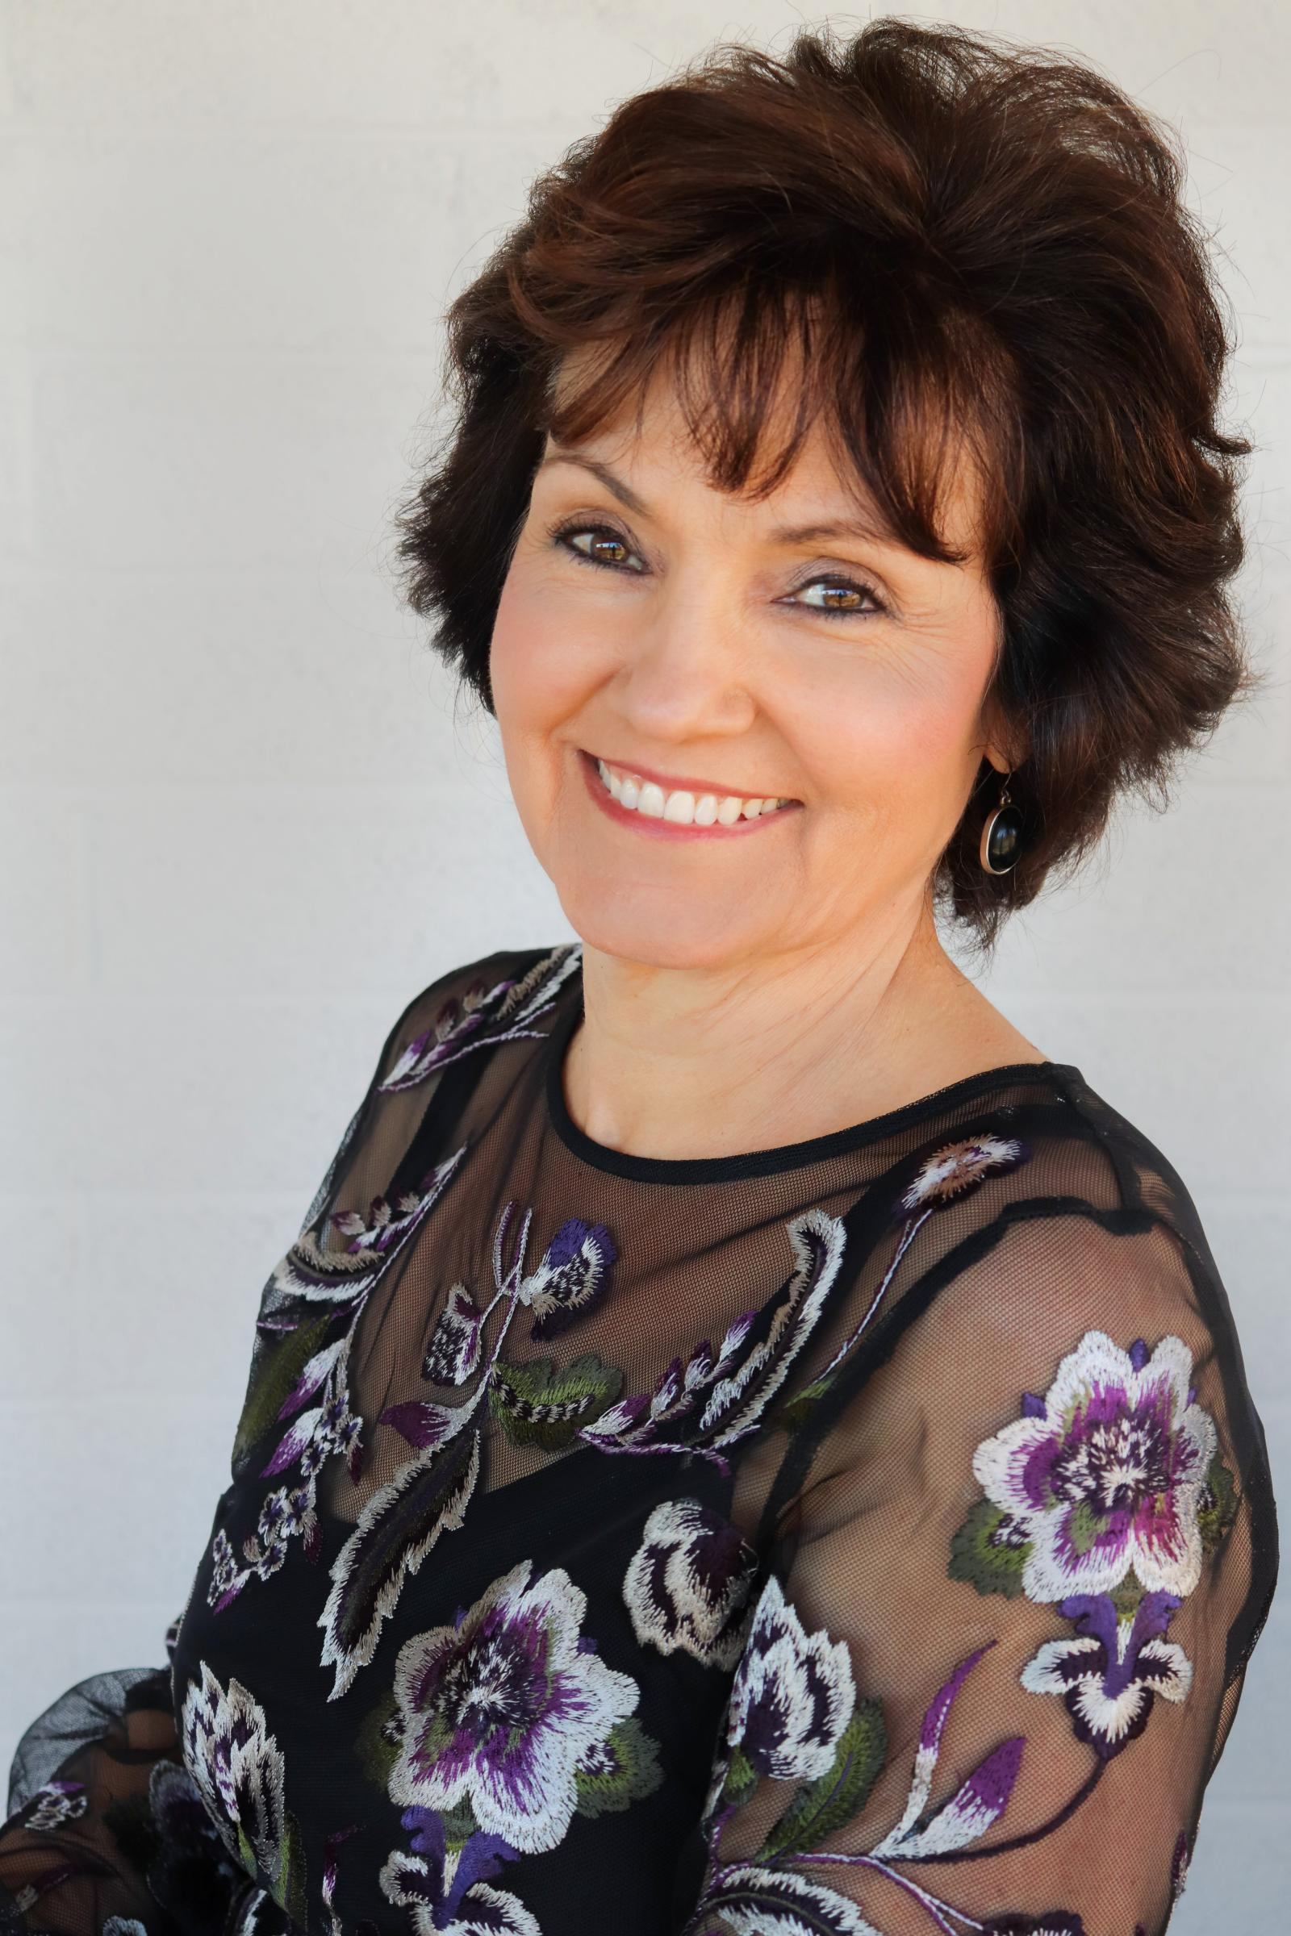

Better Home Living

**April 2019**

**Volume 10, Issue 4**



***The Newsletter That’s Both Informative and Fun!***

**Family-friendly board games to go big into AR**

Fun for the family or parties, the favorite drawing game Pictionary is going high tech this year.

In June, Mattel is expected to introduce an Augmented Reality version of the popular game. Once, earthlings used paper to draw pictures as clues for people to guess a secret word. With the AR version, as you might expect, the paper is gone. Instead, players use a wand to draw in the air and the image appears on their phone, tablet or smart TV screen.

And, no, the player drawing in the air can't see what they are drawing, which judging by most Pictionary games, won't make hints any worse than they are on paper.

Many AR games are already on the market for mobile phones but this is one of the few aimed at the family/party group market where being in the same room with other gamers is important.

According to Cnet.com, we will soon be seeing AR versions of Clue, The Game of Life, and others.

***Free Cleaning Tips and Specials at www.MyWebsite.com***

**Hello April!**



**News from Home**

**Cleaning faucet aerators**

Aerators keep the water flow of faucets from splashing about when you turn the faucet on. They contain a metal screen circle that does the job.

Ideally, the water then has a lovely circular flow of combined air and water. Sometimes, the water stream is shaky or crooked. It happens when the metal screen has become partially clogged.

You can remove the screw-on device that holds the screen and use a toothpick to unclog holes. Or put the screen in vinegar to soak overnight.

If that doesn't work, a new screw-on device costs only about $5.

The aerator is an environmentally friendly device. It limits water flow by mixing it with air.

**How to store candles**

Put your candles in a dark, cool, dry place. Light causes their colors to fade. Heat can make the candles warp, and moisture will make the wicks difficult to light.

**Go green at the supermarket**

Most shoppers have accumulated two or more tote bags designed for grocery shopping. But they leave them at home. Make it more likely you will use them.

* Put a couple of totes in the back seat or trunk of your car.

* Buy brightly colored, washable bags so you will notice them, usually available at stores and flea markets for about $1.

Help to protect the environment by avoiding bag waste.

**Whoop it up on Arbor Day**

Perhaps you thought Arbor Day was an austere kind of a day devoted to all things serious about trees. And to a large extent, it is.

But did you know Arbor Day is also a great time to party with trees? Why not try this fun tree project with your family and friends: Make a tree famous.

Find a majestic tree in your town and make it famous -- or at least try. The best way is to make an official submission to AmericanForests.org, which keeps a database of fantastically large trees by state.

The rules require you to measure the height and width of a tree, its crown spread and find the 'points.' This can be done with a 100-foot tape measure and yard stick, believe it or not. This measuring technique, described on the site, would be a good trigonometry lesson for high schoolers. Short cut: You can also use a smartphone these days to make the calculations with apps like Theodolite. Your tree publicity efforts will also require you to take photos, get a GPS location, and find the scientific and common name of the species.

The state natural resources department usually has a database of big area trees. You could also try submitting your tree there.



I hope you enjoy this month’s newsletter!

Mari and Staff

Orange Carrot Zucchini Cake with Coconut Cream Cheese Frosting

**Ingredients**

* 3/4 cup plain Greek yogurt
* 2 1/2 cups of whole wheat pastry flour
* 2 teaspoons baking soda
* 1/4 tsp of salt
* 2 tsp of cinnamon
* 1/2 tsp of nutmeg
* 1/2 cup of unsweetened shredded coconut
* For the Frosting:
* 4 oz reduced fat cream cheese
* 3 tbsp organic powdered sugar
* 3 tbsp unsweetened coconut milk (canned or carton is fine)
* 1/3 cup of unsweetened coconut flakes
* 1 cup of shredded zucchini, squeezed well of all moisture
* 2 cups of shredded carrots   
   (from about 4-5 medium carrots)
* 1 apple, peeled and shredded
* 2 large eggs, at room temperature
* 1/2 cup of pure maple syrup
* 1 tbsp of vanilla extract
* 1/2 cup coconut oil, melted and cooled
* 3/4 cup of of freshly squeezed orange juice
* zest of 1 large orange

**Instructions**

1. Preheat oven to 350 degrees F. Spray 12 cup Bundt pan generously with nonstick cooking spray.
2. In a large bowl, combine flour, baking soda, salt, spices; stir well with a whisk.
3. In a separate large bowl mix together all wet ingredients: zucchini, carrots, shredded apple, eggs, maple syrup, vanilla extract, coconut oil, orange juice, zest and yogurt. Mix wet ingredients with dry ingredients until just combined. Fold in shredded coconut flakes. Pour batter into Bundt pan. Bake for 40-55 minutes or until wooden toothpick inserted in the center comes out clean. Transfer to wire rack for 10-15 minutes, then invert cake onto rack and allow to cool completely.
4. To make cream cheese frosting: In a medium bowl, beat the cream cheese, powdered sugar and coconut milk together. Spread over the top of the cake. Top with the unsweetened coconut flakes. Serves 16.

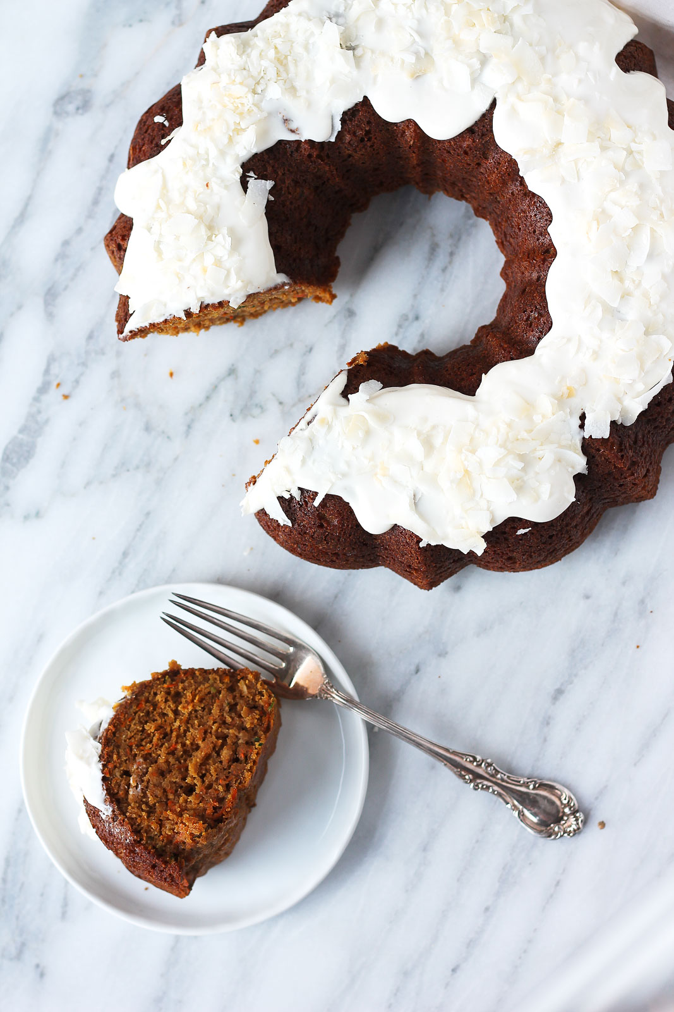

**Notes**

Optional add-ins: 1/2 cup chopped pecans or walnuts, 1/2 cup of crushed pineapple, 1/2 cup raisins -- all would be delish!  
  
You can also bake this cake in a 9x13 inch pan, but remember to reduce the baking time. I would check around 30 minutes.  
  
Make these into cupcakes by reducing the baking time to 20-25 minutes, or until toothpick comes out clean!

**Trivia Teaser –****What a Scandal!**

1. The Teapot Dome bribery scandal occurred within the administration of which US President? a-Warren G. Harding,

b-Andrew Johnson, c-Calvin Coolidge,

d-Herbert Hoover.

2. Which actress was censured by the U.S. Congress in the 1950s after deserting her Swedish husband and children for film director Roberto Rossellini? a-Hedy Lamarr, b-Vivien Leigh, c-Ava Gardner, d-Ingrid Bergman.

3. Who saved his political career from a scandal with the dramatic "Checkers" speech in 1952? a-Richard Nixon, b-Harry Truman,

c-Joseph McCarthy, d-John Foster Dulles.

4. During the Black Sox Scandal in the 1919 World Series, Chicago White Sox players conspired with gamblers to intentionally lose against which team?

a-Brooklyn Dodgers, b-Cincinnati Reds,

c-Philadelphia Athletics, d-New York Giants.

5. In which scandalous novel is literature professor Humbert obsessed with pre-teen Dolores Haze? a-"Catcher in the Rye,"

b-"Lolita," c-"Lady Chatterley's Lover,"

d-"Under the Volcano."

6. Which governor's bid for the presidency in 2016 is hampered by the George Washington Bridge scandal? a-Ron DeSantis, b-Chris Christie, c-Tony Evers, d-Ralph S. Northam.

7. Which game show emcee returned from exile for his involvement in the "21" scandal to host "The Joker's Wild"? a-Bill Cullen,

b-Gene Rayburn, c-Jack Barry, d-Wink Martindale.

8. Which NBC news anchor was demoted for claiming he was aboard a military helicopter hit by a missile while covering the Iraq War in 2003? a-Roger Mudd, b-Frank McGee, c-Brian Williams, d-Bob Woodruff.

9. Who resigned as the president of the NAACP chapter in Spokane, Washington after she was exposed as a white woman passing for black? a-Rachel Dolezal, b-Elizabeth Warren, c-Martina Big, d-Melissa Harris-Perry.

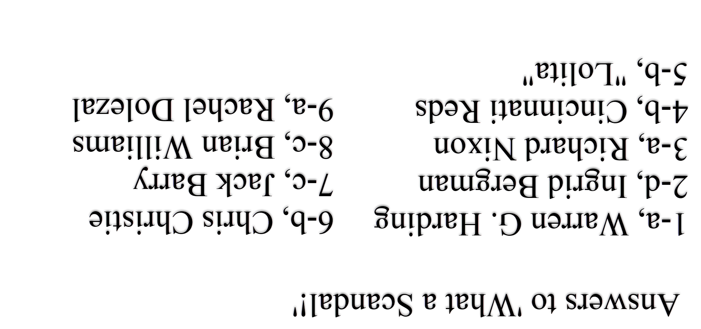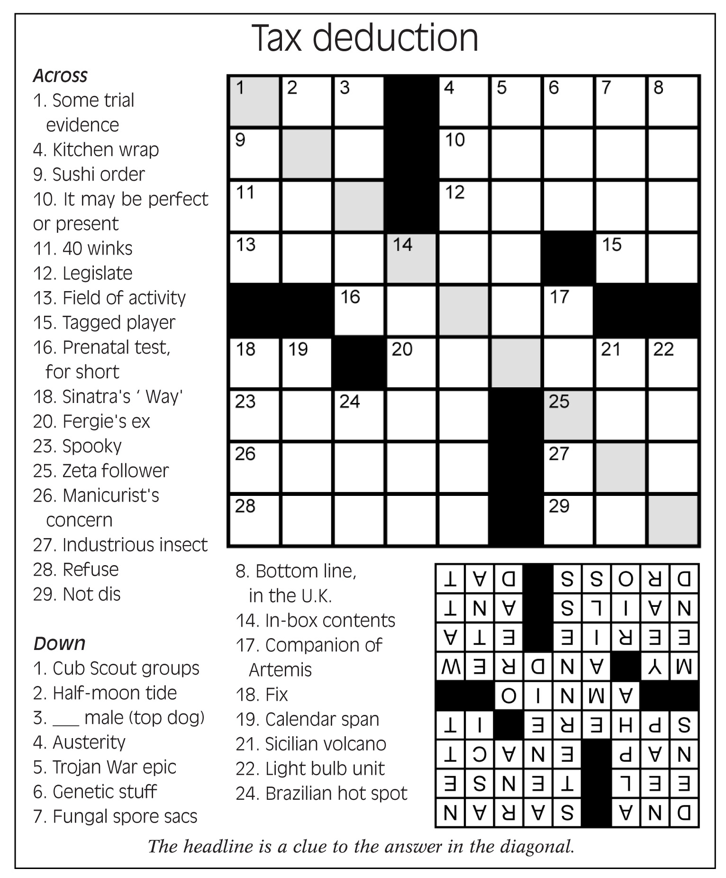

**Why would you want a salt lamp?**

It sounds a little odd at first: a lamp that looks like a pink or salmon-colored geode and is made out of a hunk of salt.

Would it make you thirsty? Would your sinuses get overly dried out? Is it a little too new-agey?

Himalayan salt lamps are hugely popular right now, thanks in no small part to celebrity mentions and the popularity of sea salt in general. The theory with the lamps is that the salt absorbs allergens and dust in the home via negative ions, thereby purifying the air (the nasty stuff has all positive ions, the thinking goes, and the lamps neutralize the charge).

While the detoxifying benefits of salt have a long history -- or even the bonuses provided by a saline flush -- studies on the effectiveness of the lamps are hard to come by. The good news is that you can find them everywhere and give one a try for as little as $20 or so. And fans point to the calming glow of the lamp as much as any other attribute.

As for the pink and the Himalayan? An article on Time.com said pink Himalayan salt "is made from rock crystals of salt that have been mined from areas close to the Himalayas, often in Pakistan. It gets its rosy hue from trace minerals in the salt, like magnesium, potassium and calcium."

Perhaps you have hibiscus in your garden this year...but have you eaten any lately? Not the flower, per se, but anything hibiscus-flavored.

If not, you are lagging behind on a 2019 food trend. According to Firmenich, the world's largest privately-owned fragrance and flavor company, hibiscus is the flavor of the year for 2019, "based on the growing appeal of florals in food and drink, and the trend towards curiosity in consumption."

It is natural, floral, and slightly tangy, according to a press release issued by the company. The company also noted some "mirroring" between hibiscus and Pantone's Color of the Year, Living Coral.

And, according to the company's research, the worldwide use of hibiscus in food and beverage new product launches has increased nearly 300 percent compared to 2012. Top categories: yogurt, beer, tea, and chocolates. It is also popular for infusing water.

Hibiscus has been used in health remedies for centuries, and Firmenich said "recent studies show promise for both the tea and the hibiscus plant extract to lower blood pressure and cholesterol levels."

Aside from its yumminess in cold drinks and in hot teas, hibiscus has savory applications as well. Firmenich noted that hibiscus has been used in Mexican cuisine, like traditional ceviche recipes and in trends including enchiladas and dried hibiscus garlic chips.

Hungry yet?

**What can be done about plastic?**

Although "Plastics" may have represented the future as envisioned by the adults doling out advice to a young Dustin Hoffman in the movie The Graduate, "removing plastics" is more aligned with the current day's theme.

And a college dropout of about the same age as Hoffman's character has famously set out to rid the Pacific Ocean in particular of the plastics that have collected there for 60-some years.

Dutch inventor Boyan Slat, 24, created a system intended to clean up the Great Pacific Garbage Patch -- a plastic debris field located between California and Hawaii that has become twice the size of Texas -- in five years' time. The garbage catcher, "System 001," launched in Sept. 2018 to great fanfare and backed by thousands of investors.

How has it fared thus far? It's received mixed reviews. The device's 2,000-foot-long screen broke apart just before New Year's and had to be towed in for repairs.

Although the device hadn't yet captured the plastic it was built for, Slat said in interviews that he and his team of 80 engineers and oceanographers expected a year's worth of back-and-forth with the prototype. Some type of breakdown was to be expected, he said, and although disappointed, Slat and his team intend to continue their work.



**Flavor of the Year is a flowery treat**

“Let my teaching fall like rain and my words descend like dew, like showers on new grass, like abundant rain on tender plants.”

**Deuteronomy 32:2**

**A mental error that can keep you in debt**

Maybe a little debt doesn't feel too bad, but sooner or later people ask themselves, "Is it too much?".

That's when they start comparing themselves to peers. Friend A goes on a cruise twice a year. Debt doesn't seem to be an issue. Friend B doesn't make a lot of money but is still a credit card clothes horse.

According to financial blogger Michelle Schroeder-Gardner, comparing yourself to others is false security. It makes you think debt is normal. It also makes you think you can afford to have it.

Take the Trivia Challenge

**How old is Dutch inventor Boyan Slat?**

**a. 24 b. 45 c. 60 d. 80**