

**Better Home Living**

**Volume 10, Issue 6 2212121212121121278811**



**June 2019**

***The Newsletter That’s Both Informative and Fun!***

**Fathers in film have changed over time**

It's the month that celebrates Father's Day, which makes it a good time to reflect on the ways fathers have been portrayed on TV.

Dads have traveled quite the route, starting with the 9-to-5 businessman who steered the household, steady and secure. The family around him provided most of the antics, while Father was the straight man -- think Ward Cleaver in Leave it to Beaver.

Then there was Andy Griffith, which introduced a single father into the mix. The widowed and wise Griffith was sheriff of the sleepy town of Mayberry and had a young son, Opie. As good a guy as he was, however, Griffith still needed a woman's influence and help in raising Opie; he lived with his Aunt Bee.

By the 1970s and 1980s, TV saw a mix of fatherly styles, from the ranting Archie Bunker of All in The Family and the put-upon George Jefferson of The Jeffersons to the more serene Mike Brady (again, a widower) and the blended family dynamics of The Brady Bunch. There was also the dual income family with Heathcliff Huxtable as the goofy-but-paternal father in The Cosby Show.

The 1990s brought us the bumbling, even somewhat miserable dad -- with Al Bundy arguably kicking off the genre in Married with Children -- and the clueless guy. It also introduced the uncle who steps into the father role, with Uncle Phil in The Fresh Prince of Bel-Air.

Fast-forward to the 2000s and we've got a mix, including same-sex couples (Modern Family), stay-at-home dads (Parenthood), and the wisecracking but lovable dad of The Last Man Standing.

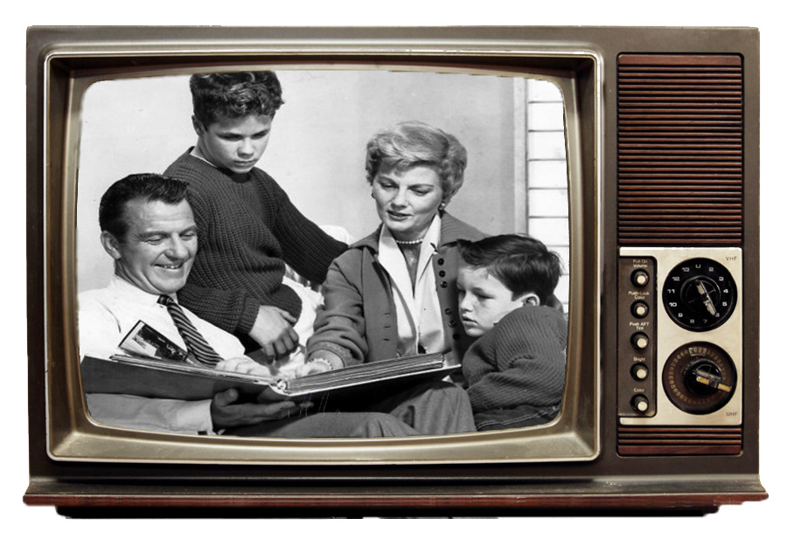

**Why refrigerate eggs?**

In most countries, eggs are stored on an unrefrigerated shelf.

Although this can be jarring to North Americans, it isn't that far out. After all, hens do not lay in refrigerators.

So why do we keep eggs cool? It is one way to fight salmonella contamination.

In the U.S., egg producers must wash eggs to remove contaminants. This process also removes a natural coating on the egg, leaving it porous. So the washed eggs must be immediately refrigerated and stay that way. A washed egg, if left at room temperature, may sweat, allowing the growth of bacteria that could enter the egg through the shell, according to eggsafety.org.



**To keep the bedroom healthy, keep on dusting**

The dust that accumulates on your furniture, floors and knickknacks has nothing to do with poor housekeeping. It's a natural and continual collection of stuff caused by microscopic dust mites, the breakdown of fibers from household fabrics and furniture, and human and animal dander (skin flakes).

The average house in the United States collects about 40 pounds of dust each year, says allergist William Berger, author of Asthma and Allergies for Dummies.

Dust is a large part of indoor air pollution, mainly because people spend about 90 percent of their time indoors, says the Environmental Protection Agency. And dust can trigger allergies and asthma attacks.

While you can't eradicate dust altogether, there are steps you can take to reduce its accumulation. The first step is getting rid of clutter.

Things like books, clothing, and stuffed toys are big collectors of dust. So are pennants and posters kids tack to their walls.

Molly Hooven, an EPA spokeswoman, suggests concentrating dust-fighting efforts on bedrooms, because you spend about one-third of your time there. Some things you can do:

* Remove extra furniture and any objects that will give dust mites a place to land on.

* Vacuum the bedroom carpet using a vacuum cleaner with a HEPA filter. Vacuuming can eliminate dust mites that have settled on the floor.

* Clean surfaces such as your vanity, television, side tables and headboards with a damp cloth or a cleaning furniture polish. Close closet doors.

* Wash your bedding. Use 140-degree water to eliminate dust mites.

* Place stuffed animals and fabric items that can't be machine-washed into plastic bags and freeze, which will eliminate dust mites.

I hope you enjoy this month’s newsletter!

Mari & Staff

**INGREDIENTS**

2 medium ripe bananas (best when they have lots of brown spots)

2 eggs

1/2 cup unsweetened almond milk

1 teaspoon vanilla extract

1 ½ cups old fashioned rolled oats, gluten free if desired

2 teaspoons baking powder

½ teaspoon ground cinnamon

¼ teaspoon salt

Olive oil, for cooking

Banana Oatmeal Pancakes



**INSTRUCTIONS**

Add all of the ingredients to a blender and blend on high until completely smooth, about 30 seconds to 1 minute. Let the batter sit in your blender while you heat your pan up.

Lightly coat a griddle with coconut oil, vegan butter or olive oil and place over medium heat. Once pan is hot, add 1/3 cup of the batter to the griddle for each pancake and cook for 2-4 minutes until pancakes slightly puff up and you see a few bubbles along the edges.

Flip cakes and cook until golden brown on underside. If you find that pancakes are browning too quickly then you need to lower the heat. I normally start on medium heat, then decrease to medium low later so that my pancakes don't burn. If at any point your griddle starts smoking, it means your pan is too hot.

Wipe skillet clean and repeat with more oil and remaining batter. Makes 9 pancakes total. Serves 3, 3 pancakes each.

“Then you will know the truth, and the truth will set you free.”

John 8:32



**Trivia Teaser –****Fox Hunting**

1. Jamie Foxx won an Academy Award for his portrayal of which singer? a-Ray Charles, b-Scott Joplin, c-James Brown,

d-Jackie Wilson.

2. Which German field marshal of World War II was nicknamed "The Desert Fox"?

a-Heinrich Himmler, b-Gerd von Runstedt, c-Joachim von Ripentrop, d-Erwin Rommel.

3. "Fox on the Run" was a 1974 hit song for which band? a-Rare Earth, b-Sweet,

c-Ram Jam, d-Kiss.

4. Fox Mulder was an FBI agent on which TV series? a-"The X-Files,"

b-"Fringe," c-"Harsh Realm," d-"Falling Skies."

5. Which of the following is NOT true about the bat called the flying fox? a-It eats fruit, b-It gives live birth, c-It navigates by echolocation, d-It is nocturnal.

6. What is the name of Peter and Jason's sister in the comic strip "FoxTrot"? a-Jamie, b-Paige, c-Alicia, d-Luann.

7. Which actor starred in the 1966 film comedy "After the Fox"? a-William Shatner, b-Frank Sinatra, c-Peter Sellers,

d-Cary Grant.

8. Triple Crown-winning thoroughbred Gallant Fox was the sire of which other Triple Crown winner? a-Omaha, b-Man o' War, c-Seabiscuit, d-War Admiral.

9. Who played the title character in the movies "Foxy Brown" in 1974 and "Jackie Brown" in 1997? a-Teresa Graves, b-Jeanne Bell, c-Andrea King, d-Pam Grier.

10. What is the name of the thieving fox on the kids' show "Dora the Explorer"?

a-Raymond, b-Hunter, c-Swiper, d-Ozzie.

11. "The Chairman Dances: Foxtrot for Orchestra" is a 1985 work from which American composer? a-John Adams,

b-Philip Glass, c-Steve Reich, d-Peter Sellars.



**Ideas for falling asleep fast**

Fatigue is a safety issue that affects every aspect of life and work. But some people spend enough time in bed, they just don't sleep.

From night-to-night there could be different reasons why you can't fall asleep.

Ask yourself why. Are you:

Feeling wide awake? You might have to change your schedules and habits. Caffeinated drinks like coffee or soda can have lasting affects into the night.

Too much bright light before bed can keep your body in wake mode. Turn down lights. Turn off phones and e-readers.

Reliving the day? New sleep apps can help put aside the day's events with meditation or even bedtime stories. The app Calm allows you to choose a 15- to 30-minute bedtime story that tends to replace thoughts of current events. The tales get progressively softer until they just stop. Still not asleep? Do another.

Feeling stressed and excited? You could try Dr. Andrew Weil's 4-7-8 method of going to sleep. The technique puts your body into relaxation mode, acting like a tranquilizer.

* Let your lips part and make a whooshing sound as you exhale completely.

* Close your lips, then inhale silently four times through your nose.

* Hold your breath for seven seconds.

* Make a whooshing sound and exhale from your mouth for eight seconds.

* Do this four times and work up to eight, if necessary.

**Great gift ideas for a college graduate**

Graduating from college is an important milestone that deserves to be celebrated.

If you are stuck on what to get, consider buying the grad something for their new home, their new job, or even a memorable experience.

According to USA Today, college graduates have probably been getting by with shorts and T-shirts for the past four years. Now is the time for professional clothing. New suits or dresses are a great start, followed by accessories such as business card holders, watches, handbags, or briefcases. Some might need a high-quality suitcase or weekend bag; reliable options that will last them for years.

For graduates that are moving for a new job or just moving out of the house, practical gifts like an instant pot, microwave, or coffee maker could be a solid choice. It is likely that they may need some help in this area as well, so a few cookbooks could help them choose to cook at home more often. For those that lived in furnished apartments or dorms, other household goods such as linens, towels, and living room furniture might be welcome. Better check with the grad when it comes to style, though.

There are few better ways to celebrate an accomplishment than going on a trip. Consider booking a cruise or buying a flight and hotel room in a city that they have always wanted to visit.

Throw in a new camera, not attached to a smartphone, and they will have new experiences to share.

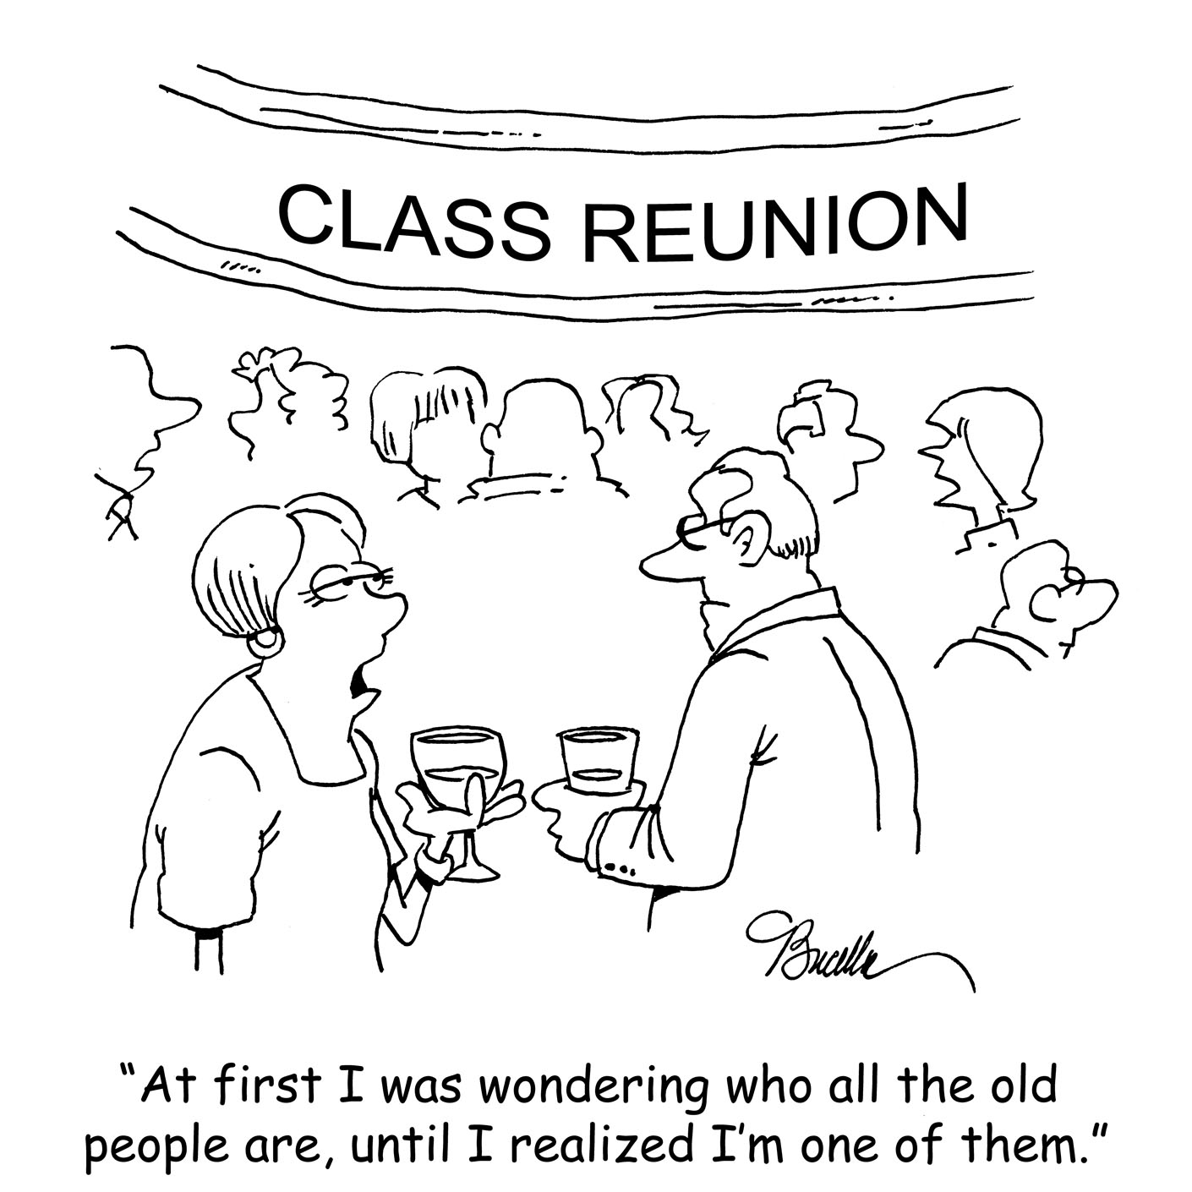

**Skin Cancer 101**

For decades, we've passed on the baby oil in favor of slathering on sunblock. The public health campaigns that warned of the dangers of skin cancer were effective, though some questions still remain.

How does one develop skin cancer and why is it so serious?

According to skincancer.org, most skin cancers are associated with ultraviolet (UV) rays from the sun and tanning beds, with UV damage causing DNA damage to skin cells. This triggers mutations or genetic defects that lead the skin cells to multiply rapidly and form malignant tumors.

However, certain skin cancers are caused by other factors like genetics or other environmental influences and may even occur on parts of the body that are rarely exposed to the sun. Darker-skinned people are more susceptible to acral lentiginous melanoma (ALM), an especially virulent form of melanoma that typically appears on the palms of the hands and soles of the feet, according to the site.

More people are diagnosed with skin cancer each year in the U.S. than all other cancers combined, with about 90 percent of nonmelanoma skin cancers associated with exposure to UV from the sun. Basal cell carcinoma is the most common form of skin cancer (4.3 million cases diagnosed in the U.S. each year), with squamous cell carcinoma second (more than 1 million cases).

The website says an estimated 192,310 cases of melanoma will be diagnosed in the U.S. in 2019.

Melanoma is particularly dangerous because it is more likely to spread to other parts of the body if not caught early.

The good news is that all types of skin cancer are quite treatable if caught early, so prevention and detection are key. In addition to checking your body for signs of abnormalities, most health professionals advise the use of a sunscreen with SPF of 15 or higher and to limit your exposure to direct sunlight between 10 a.m. and 2 p.m.

**Go on a money date**

Ever heard of a money date? It's a thing. On a money date, spouses agree to get together to talk finances in a (allegedly) fun and non-threatening way. The idea is to keep on top of budgets and, perhaps more importantly, to work together on goal setting.

The idea is to keep it affordable, so that might entail staying home with a good bottle of wine. Pro Tip: tackle the heavy lifting issues prior to finishing that first glass.

For singles: you can take yourself on a money date, too. This thing with money IS a relationship.