

**Volume 10, Issue 1 2212121212121121278811**



**January 2019**



***CleaningSolutionsByMari.com***

**Donate blood in January**

Just 10 percent of the eligible blood donors actually donate blood.

The most common reason? They just didn't think about doing it. That's why January has been named National Blood Donor Month since 1970.

Every day, hospitals and clinics around the country need about 36,000 units of blood and 7,000 units of platelets to help save lives. As an example, a single victim of a car accident could require as many as 100 pints of blood throughout their treatment and recovery process.

It is crucial to increase awareness around these donations, especially among those with Type O blood, which can be transfused into any other blood type and is only represented in seven percent of the total population. AB positive individuals, meanwhile, are universal donors of plasma and make up only three percent of the population.

The blood drawing process is entirely safe and the donation itself usually takes less than 15 minutes. Even first-timers can likely register, go through their medical history and a mini-physical, and complete the gift in under an hour and a half. Because donated blood typically has to be used within 42 days, regular contributions are crucial throughout the year.



I hope you enjoy this month’s newsletter!

Mari & Staff

**10 Things that should be thrown away now**

Some things are wasteful to keep. They waste space and your energy.

Here are 10:

1. Old medications. A year after the expiration date, just pitch it.

2. Scratched non-stick cookware. You hate it anyway. No one else wants it.

3. Old sneakers. When they get old, they break down. No one else can use them.

4. Old plastic containers. Discolored. No lids. You hate them. Pitch them.

5. Liquor. It's junk after it has been opened and sitting in your cabinet for a year.

6. Old cosmetics. Not even you use that broken up stuff. Pitch it.

7. Creams and lotions. If they are more than a year old, they are trash.

8. Old cleaning tools. When the tool looks worse than the thing it is supposed to clean, get rid of it.

9. Random socks. If you want to, then do a massive sock match. But otherwise, in the trash.

10. Paperbacks. This can be hard for book lovers but remember even the library throws away books. Old, dusty paperbacks do little besides take up space. Recycle them if you want. Or try to give them away. But get rid of them.

**Celebrate the new year with one-day projects**

Maybe instead of making a long-term new year's resolution ("I will save money all year!"), you could try doing one satisfying thing.

Here are some choices:

Clean up your computer

Start with photos. You probably have a lot of them from the last year and this is a great way to reminisce while usefully deleting the junk. You can rename photos to make them searchable. If you are feeling organized, make some coherent groups for them.

Programs and downloads are next. Chances are last year you added a dozen or so junk apps and downloaded the same pdf three times. Clean out those downloads and programs. Uninstall properly.

Email. You have a ton of stuff you will never look at.

Old computers. Shouldn't you do something with them besides just storing them? Remove the hard drive first and then recycle.

Get organized

On a lot of people's resolution list, getting organized can streamline your life. Maybe instead of saying you'll organize everything, you could pick a project you can do in one day.

The closet, and all those clothes that don't fit. If you do lose weight, you won't want to wear them anyway.

File cabinets and all those files you can't find. Buy a labeler and simplify.

Kitchen, seriously how many crockpots and coffee cups do you need?   
Garage, can you ever find a tool?

Ruthlessly winnow down possessions: Throw away, recycle, donate.

Need something simpler?

Donate blood. There is a month for that and it's January. Go to redcross.org/blood for information.

Moderate your tone on Twitter

Just for one day in honor of the United Nations International Year of Moderation. On social media, spend one day promoting dialogue by extending mutual respect and understanding. Absolutely no sarcasm.

***The Newsletter That’s Both Informative and Fun!***



**Baked Mini Corn Dogs**

**Ingredients**

1 cup reduced-fat milk

1 package active dry yeast

2 tablespoons extra-virgin olive oil, plus more for greasing

2 tablespoons packed light brown sugar

1 cup fine yellow cornmeal

1 1/4 cups all-purpose flour, plus more for dusting and kneading

1 teaspoon salt

1/4 teaspoon baking soda

1/4 teaspoon cayenne pepper or paprika

9 reduced-fat hot dogs, halved crosswise

1 large egg, beaten

1 tablespoon black sesame seeds (optional)

**Directions**

1. Warm the milk to about 110 degrees in a saucepan; pour into a medium bowl. Sprinkle in the yeast and let soften for about 2 minutes. Stir in the olive oil, brown sugar and cornmeal with a wooden spoon. Add the flour, salt, baking soda and cayenne pepper; stir to make a sticky dough.
2. Turn the dough out onto a lightly floured surface and knead, adding more flour if needed, until smooth but still slightly tacky, about 5 minutes. Shape the dough into a ball, place in a lightly oiled bowl and cover with plastic wrap. Let rise in a warm spot until doubled in size, 45 minutes to 1 hour. Meanwhile, insert a wooden stick or small skewer into each hot dog half, about 1 inch deep; set aside.
3. Preheat the oven to 450 degrees and lightly oil a large baking sheet. Turn the dough out onto a lightly floured surface; divide into 18 pieces. With your palms, roll each piece into a 10-inch length. Wrap each piece around a hot dog half, tucking and pressing the edges to seal; place on the baking sheet.
4. Brush the dough-wrapped dogs with the beaten egg; sprinkle with sesame seeds, if desired. Bake until golden, 15 minutes

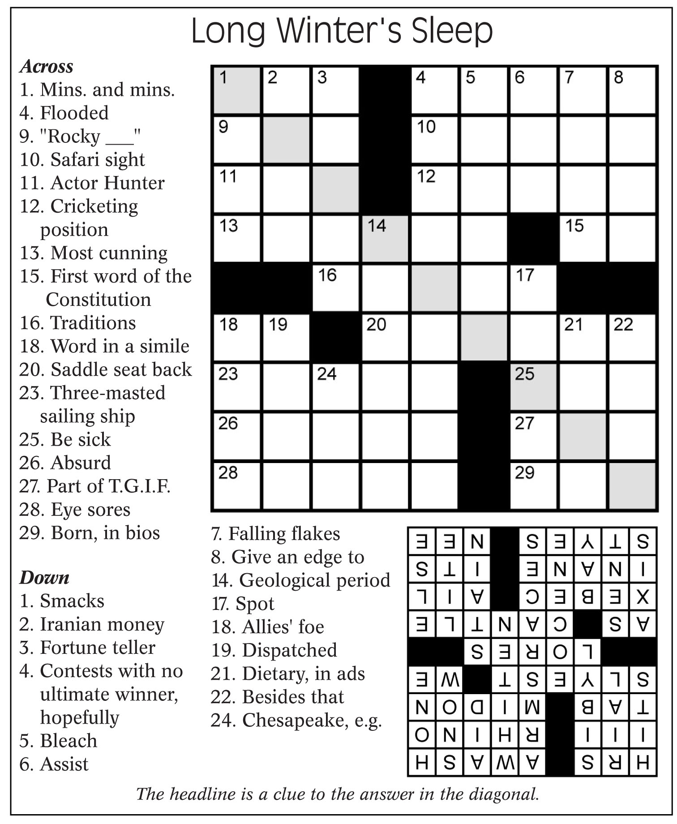

**Trivia Teaser –  
Two-Wheelers**

1. Which term was used for a bicycle with a large front wheel and smaller back wheel? a-Chicken bone, b-Penny farthing, c-Big cheese, d-Pillion rider.

2. Before becoming successful aviators, the Wright Brothers ran a bicycle repair shop in which city?

a-Kansas City, Missouri, b-Dayton, Ohio,

c-Tulsa, Oklahoma, d-Vancouver, Washington.

3. Which British band had a hit song in 1978 with "Bicycle Race"? a-Queen,

b-AC/DC, c-The Who, d-Deep Purple.

4. In which American landmark does Pee-wee Herman hope to find his stolen bicycle in "Pee-wee's Big Adventure"?

a-The Statue of Liberty, b-Mount Rushmore, c-The Alamo, d-The Old North Church.

5. Who receives a marriage proposal in the song subtitled "Bicycle Built for Two"? a-June, b-May, c-Marguerite, d-Daisy.

6. Which song is heard as Paul Newman and Katharine Ross ride a bicycle in "Butch Cassidy and the Sundance Kid"?

a-"Moon River," b-"(I've Had) The Time of My Life," c-"Windmills in My Mind,"

d-"Raindrops Keep Falling on My Head."

7. The Trek Bicycle Corporation has its headquarters in the city of Waterloo in which state? a-Indiana, b-Ohio,

c-Wisconsin, d-Michigan.

8. Which cubist artist's "Bull's Head" sculpture was made from a bicycle seat and handlebars? a-Salvador Dali, b-Pablo Picasso, c-Marcel Duchamp, d-Piet Mondrian.

9. Which country won the Best Foreign Film Oscar of 1949 for the movie "Bicycle Thieves"? a-Italy, b-Turkey, c-India,

d-Japan.

10. The car and bicycle manufacturing divisions of which French company were divided in 1926? a-Renault, b-Citroen,

c-Peugeot, d-Bugatti.

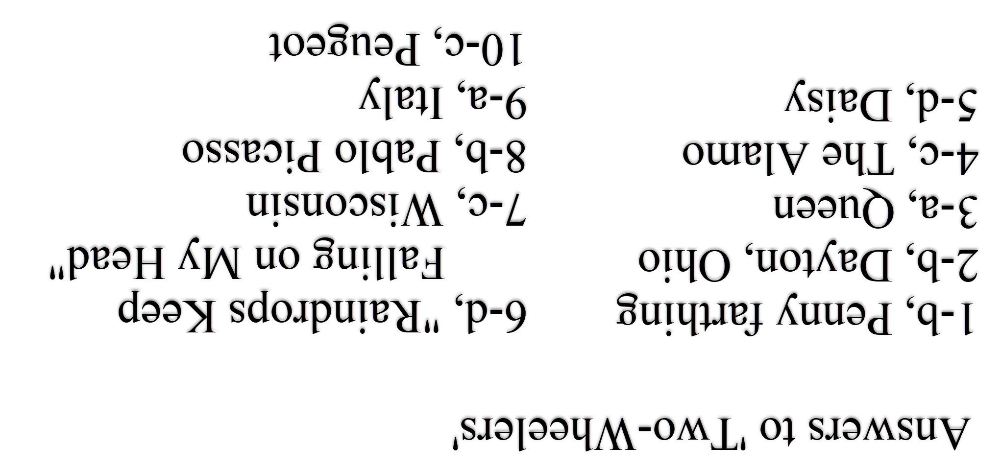

**Use your checking account wisely? Your credit score could now go up**

This year, people who wisely manage their checking accounts could see an increase in their credit scores.

The new UltraFICO credit score will let some consumers offer their banking activity as proof that they are credit worthy.

A credit score has never been based on income. A person who makes $20,000 per year -- and pays loans faithfully -- could have a higher credit score than a person making $200,000, who doesn't pay loans on time. The credit score tries to predict if a person will pay back a loan and pay it back on time.

Some people, especially younger people, may not have much of a history of loan payments. Those people pay for things mainly in cash, and through their checking accounts and debit cards, which aren't counted toward a credit score. If they do apply for a loan, their lack of credit history could put them in the subprime category, scores below 670. They might be denied credit.

With the UltraFICO scoring system, a lender can offer to recalculate a consumer's score based on banking activity. People who have had a checking account for some time, maintain a balance of about $400, and don't overdraw are likely to see their score rise, possibly high enough to get a loan and therefore build credit history.

One caution: those who do overdraw their accounts could see their scores go down in an UltraFICO calculation.

Since the subprime mortgage crisis, banks have been focused on only the most creditworthy borrowers. In 2018, a record 58.2 percent of U.S. consumers held a score between 700 and 850, the FICO maximum. These high-score consumers aren't taking out as many loans these days and lenders have been eager to find responsible borrowers.

Fair Isaac Corporation, the creator of the widely used FICO score, estimates 7 million people with thin credit histories could benefit from an UltraFICO recalculation. Another 26 million people could see an increase, and 4 million could see their score increase 20 points.

**When negative thoughts constantly intrude, take action**

People tend to be their own worst critics, but when negativity constantly dominates thoughts, it is time to take some action.

Here are what psychologists quoted in Psychology Today recommend:

"When you find yourself going down the path of self-criticism, gently note what is happening," advises mediation specialist Allan Lokos.

Be curious and warn yourself that these are thoughts, not facts. During such moments, psychologist Thomas Boyce recommends immediately jot down as many positive things you know about yourself.

You can also accept the presence of negative thoughts but reject thoughts that involve comparing yourself to others. Social media can be a 24-hour menace to a person's self-esteem. Kimberly Hershenson, LMSW, warns that it can generate gloomy self-talk that only "leads to still more anxiety and stress." Serving others helps you focus on something other than your own issues, she says. Marriage and Family therapist David Simonsen agrees. "The more someone does something they can be proud of, the easier it is to recognize his or her worth," he says. "It is tangible. Helping at a homeless or animal shelter, giving of time at a big brother or sister organization are things that provide value to oneself someone else as well."

Recognize your strengths--and the reassurance they bring you in times of insecurity. Perhaps ask a close friend.

Debbie Mandel, the author of "Addicted to Stress," suggests replacing one task per day from your to-do list to relax or do something fun. Also be sure to eat well and get enough sleep. Both can heighten the happier aspects of your self-perception.

**Cabin Fever Workouts: When winter makes you stay home**

Let's face it: winter can be long when you're in a cold-weather location, and the gym gets old after a while. When you can't get outside, sometimes it helps to simply get a change of scenery -- even if that means a workout at home.

The good news is, you can make up your own routine. Here are some ideas to help you get started:

Lunges: This tried-and-true exercise is great for strengthening the legs and backside. Do lunges and reverse lunges to really work a variety of muscle groups.

Burpees: What better way to mix cardio and strength than this one?

Jogging in place: Do 45 seconds of tush-kicking, and 45 seconds of high knees. Take a quick break and go at it again for as many rounds as you can muster.

Pushups: Perform full pushups or modify them. Either way, you can do 3-5 rounds of a chosen number, and feel the burn.

Triceps dips: Be sure to find a solid piece of furniture that will hold you and won't move. Then do this classic exercise with your legs straight or bent and, as with the pushups, do 3-5 rounds of a certain number.

Sit-ups: Pick your favorite way to do them and get to it! Your core will thank you.

Planks: Assume the position! You know the one, where you appear poised to perform a push-up and then stay still for as long as possible. The most popular pose is with forearms flat on the floor, arms forming a 90-degree angle, and legs stretched out behind you, toes pointed down to the ground. Remember to keep your back flat.

There are any number of ways to mix things up and stay in shape. And this is your house -- play whatever music you want or put any channel you like on TV. The key to sticking with a workout is to have fun with it, after all.

*“Let the words of my mouth and the meditation of my heart be acceptable in your sight, O Lord, my rock and my redeemer.”* ***Psalms 19:14 ESV***

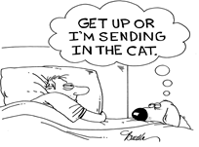

**Easy trick to limit shopping**

According to Consumer Reports, using credit cards will increase the amount of money you spend on a purchase because it makes the purchase less painful and speeds up the shopping process.

One way to slow things down is to create a buffer between the buying impulse and the checkout button. You can do this by simply removing saved credit card information from web browsers and online stores such as Amazon, according to The Simple Dollar. Actually having to take the card out of a wallet and type the information creates a powerful disincentive to purchase.

Take the Trivia Challenge

**A subprime credit score is below what number?**

**a. 400 b. 670 c. 700 d. 850**

HINT: The answer is hidden somewhere in this newsletter.